Confidence Interval: Practice 2; Confidence Intervals for Averages, unknown population standard deviation

Student learning outcomes:

- The student will explore the properties of confidence intervals for averages, as well as the properties of an unknown population standard deviation.

Given:

The following real data are the result of a random survey of 39 national flags (with replacement between picks) from various countries. We are interested in finding a confidence interval for the true average number of colors on a national flag. Let X = the number of colors on a national flag.
X | Freq.
1 | 1
2 | 7
3 | 18
4 | 7
5 | 6

Calculating the Confidence Interval

1. Calculate the following:
a. = ___________
b. sx = __________
c. n = ___________

2. Define the Random Variable, , in words.
= ___________________________________________________________

3. What is estimating?

4. Is σ_{x} known?

- As a result of your answer to (4), state the exact distribution to use when calculating the Confidence Interval.

Confidence Interval for the True Average Number

Construct a 95% Confidence Interval for the true average number of colors on national flags.

6. How much area is in both tails (combined)? α = __________

7. How much area is in each tail? 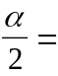 __________

8. lower limit = ________ upper limit = ________ error bound = ________

9. The 95% Confidence Interval is: _____________________

10. Fill in the blanks on the graph with the areas, upper and lower limits of the Confidence Interval and the sample mean.

______ C.L. = ______ ______
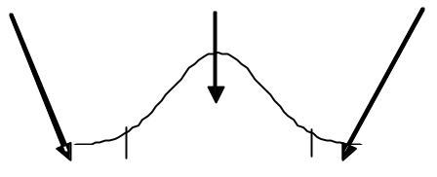
____ ____ ____

11. In one complete sentence, explain what the interval means.

Discussion Questions

12. Using the same , sx , and level of confidence, suppose that n were 69 instead of 39. Would the error bound become larger or smaller? How do you know?

13. Using the same , sx , and n = 39, how would the error bound change if the confidence level were reduced to 90%? Why?

